1C - Financial – Lesson 5
Taxation – GST & VAT

Name: _________________

- What do we mean GST?

- What is the percentage for GST? ___ %

- What is VAT?

- Use google to find the current value of VAT in . . .

  - the UK? ___ % b) New Zealand ___ %

- Assuming a GST of 10% calculate the GST on . . .

  - A pen with a pre-GST price of $3.70.
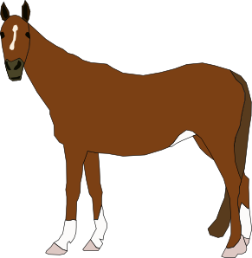
GST = 0.1 x $____ = $ ____

  - A horse with a pre-GST price of $3400.

GST = ___ x $ ______ = $ ______


  - A chair with a pre-GST price of $145.70

GST =

  - 1 kg of banana with a pre-GST price of $5.70 (Think!!!!)

GST =

- Assuming a GST of 10% calculate the Price + GST or Total Price . . .

  - A car with a pre-GST price of $32,970.

Price + GST = 1.10 x $____ = $ ____

  - A house with a pre-GST price of $340,000.

Price + GST = ___ x $ ______ = $ ______

  - A single rose with a pre-GST price of $9.00

Price + GST =

- Assuming a GST of 10% calculate the Pre-GST price when given the Total Price.

  - A cow with a total price of $540.00


Pre-GST Price = $ _______ ÷ 1.10 = $ ______

  - A book with a pre-GST price of $29.00

Pre-GST Price = $ _______ ÷ ___ = $ ______

  - A box of chocolates with a pre-GST price of $19.00

Pre-GST Price =

- Assuming a GST of 10% calculate the GST price when given the Total Price.

  - A pet cat with a total price of $132.00

GST = $ _______ ÷ 11 = $ ______

  - A computer with a total price of $2650.00

GST = $ _______ ÷ ___ = $ ______

